**NỘI DUNG HƯỚNG DẪN HỌC SINH TỰ HỌC**

**MÔN: TIẾNG ANH 6**

**WEEK 9**:

**UNIT 3: FRIENDS**

Lesson 2 (p.26, p27) (Student’s book)

**A. Grammar**

**Present Continuous for future use (Thì hiện tại tiếp diễn mang ý nghĩa tương lai)**

**Form**: **(+) S + am / is / are + V-ing.**

**Ex1**: I **am watching** a movie night.

**Ex2**: He **is making** a cake tomorrow.

**Ex3**: They **are playing** soccer on the weekend.

**(-) S + am / is / are + not + V-ing.**

**Ex1**: I **am not watching** a movie night.

**Ex2**: He **is not making** a cake tomorrow.

**Ex3**: They **are not playing** soccer on the weekend.

**(?) Am / Is / Are + S + V-ing?**

**Ex1**: What **are** you **doing** tomorrow night?

**Ex2**: **Is** he **making** a cake tomorrow?

**Ex3**: **Are** you **playing** soccer on the weekend?

* ***Dấu hiệu nhận biết của thì hiện tại tiếp diễn mang nghĩa tương lai dựa vào các từ chỉ thời gian tương lai*** (this weekend, on the weekend, on Saturday, tomorrow, tonight, this week, …)

**B. Exercises**

**Exercise 1**: **Fill in the blanks using the Present Continuous**

1. My brother ____________ (go) shopping on Friday.

2. What ____________ you _____________ (do) tomorrow?

3. I ______________ (make) a pizza tomorrow.

4. ____________ they _____________ (have) a picnic in the park this weekend?

5. She ________________ (go) to the mall with Mark on Saturday.

6. We ______________ (play) basketball this evening.

7. ____________ he _____________ (watch) a movie at home tonight?

**Key**: 1. is going 2. are, doing 3. am making 4. Are, having

5. is going 6. are playing 7. Is, watching

**Exercise 2: Write full sentences using the given words and the Present Continuous**

1. He / not / have a picnic / this Saturday.

2. I / have a barbecue / today.

3. Emma and Jane / not / watch a movie / on Sunday.

4. We / make a pizza / this weekend.

5. David / play / badminton / this evening?

6. Maria / watch TV / with her sister / tonight?

**Key**:

1. He isn’t having a picnic this Saturday.

2. I am having a barbecue today.

3. Emma and Jane are not watching a movie on Sunday.

4. We are making a pizza this weekend.

5. Is David playing badminton this evening?

6. Is Maria watching TV with her sister tonight?

**III. Pronunciation** *“What are you doing …?” often sounds like /wɒdəjədu:ɪŋ/*

**IV. Practice**

**Matt**: What are you doing **on Saturday**?

**Lisa:** I’m **having a barbecue**. Do you want to come?

**Matt:** Sorry, I can’t. I’m **watching a movie** with Jack.

**Lisa:** What about **Tuesday**?

**Matt:** I’m free. Why?

**Lisa:** I’m **having a party**. Do you want to come?

**Matt:** Sure!

**Lisa:** Great! Talk to you later.

**\*Weekend activities (*Các hoạt động cuối tuần*):** *Making a cake, going swimming, playing sports, having a barbecue, having a party, going shopping, watching a movie, having a picnic …*

**\* Giving suggestions** (Đưa ra đề nghị)

*How about / What about + V-ing / noun?*

*Why don’t we + V?*

*Let’s + V.*

*Do you want to …? / Would you like to …?*

**UNIT 3: FRIENDS**

Lesson 3 (p.28) (Student’s book)

**A. Vocabulary**

|  |  |  |  |  |
| --- | --- | --- | --- | --- |
| **No** | **Words** |  | **Transcription** | **Meaning** |
| 1 | friendly | (adj) | /ˈfrendli/ | thân thiện |
| 2 | funny | (adj) | /ˈfʌni/ | buồn cười, vui nhộn |
| 3 | helpful | (adj) | /ˈhelpfl/ | có ích, hay giúp đỡ |
| 4 | kind | (adj) | /kaɪnd/ | tử tế, tốt bụng |
| 5 | lazy | (adj) | /ˈleɪzi/ | lười biếng |
| 6 | selfish | (adj) | /ˈselfɪʃ/ | ích kỷ |

**B. Exercises**

**I. Alice wrote an essay about her best friend for homework. Does she like everything about Simon?**

My best friend is Simon. He is very **helpful**. When I can’t do my math homework, he helps me. He doesn’t like **selfish** people. That’s why he always shares his candy with his friends. I think he is very **kind**. He always thinks about other people.

Simon always makes me laugh. He is so **funny**! Lots of students in our class like him. He is very **friendly**, too. He has a lot of friends.

One bad thing about Simon is he can be **lazy**. He doesn’t like doing housework or schoolwork. That’s OK because he is my best friend!

**Key**: No, she doesn’t.

**II. Match the underlined words with their descriptions. Do the words have a good (G) or bad (B) meaning? Write the correct letter on the line.**

1. This kind of person doesn’t like working. _____________

2. This kind of person likes helping others. _____________

3. This kind of person makes others laugh. _____________

4. This kind of person is nice to others. _____________

5. This kind of person doesn’t like sharing or giving to other people. ___________

6. This kind of person thinks about other people. ______________

**Key**: 1. lazy (B), 2. helpful (G), 3. funny (G), 4. friendly (G), 5. selfish (B), 6. kind (G)

**III. Use the words in the box to fill in the blanks in these sentences**

|  |
| --- |
| helpful selfish friendly kind funny lazy |

1. My younger brother is very ___________. He never likes doing housework.

2. Tom is __________. He often helps other students in class with their homework.

3. Mr. Bean is very ____________. His movies make people laugh a lot.

4. My neighbor is ____________. She’s nice to all people.

5. Daisy doesn’t like sharing her comics with anyone. She’s really __________.

6. David is very ___________. He gets on well with most of my friends.

**Key:**  1. lazy 2. helpful 3. funny 4. kind 5. selfish 6. friendly

**C. Grammar**

**\*Asking about someone’s character (Hỏi về tính cách của người nào đó)**

What + be + S + like?

S + be + Adj.

**Ex1**: What’s he like? 🡪 He’s very **kind** but a little **lazy**.

**Ex2**: What’s she like? 🡪 She’s **friendly** and **funny**.

**UNIT 3: FRIENDS**

Lesson 2 (page 16, 17) (Workbook)

* **New words**

**a. Label the pictures**

|  |  |  |  |
| --- | --- | --- | --- |
| watch TV | make a cake | have a party | have a barbecue |
| play badminton | watch a movie | play video games | go swimming |
| make a pizza | go to the beach | go to the mall | go shopping |

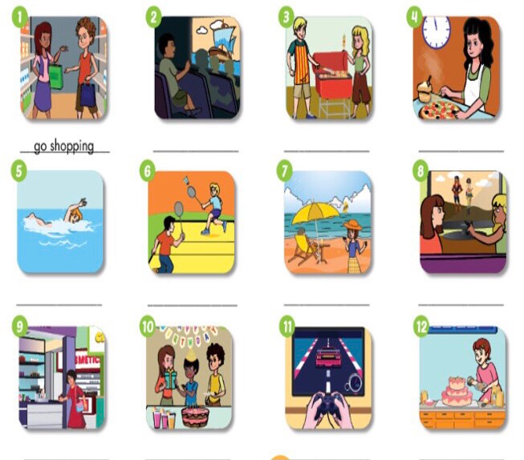

**Key**: 2. watch a movie 3. have a barbecue 4. make a pizza

5. go swimming 6. play badminton 7. go to the beach

8. watch TV 9. go to the mall 10. have a party

11. play video games 12. make a cake

**b. Fill in the blanks using the phrases in Task a.**

1. I want to _____________ to buy some winter clothes.

2. Let’s _____________. I want to go shopping and there’s a great restaurant there, too.

3. It’s a beautiful day! Let’s ___________ and swim in the sea.

4. She’s going to _______________. It’s going to have cheese and tomato on it.

5. Let’s ___________ at the movie theater.

6. I usually ________________ with my friends at school. I can hit the shuttlecock really hard.

7. My sister and I always _____________ after dinner. We really like cartoon.

8. I like to ____________ with my friends. My mom only lets me play after I finish my homework.

9. I have milk, flour, eggs, and sugar. Let’s ________________.

10. He’s going to ______________ for his birthday. I need to get him a gift.

11. It’s a lovely day. Let’s _____________ in the garden. It will be delicious!

12. I like to _____________ at the beach when it’s sunny.

**Key**: 1. go shopping, 2. go to the mall, 3. go to the beach, 4. make a pizza

5. watch a movie, 6. play badminton, 7. watch TV, 8. play video games

9. make a cake, 10. have a party, 11. have a barbecue, 12. go swimming

* **Grammar**

**a. Write the -ing form of the verbs**

1. go ____________________ 2. swim ____________________

3. play ___________________ 4. have _____________________

5. eat ____________________ 6. watch ____________________

7. make __________________ 8. study ____________________

9. do ____________________ 10. visit ____________________

**Key**: 1. going, 2. swimming, 3. playing, 4. having, 5. eating, 6. watching

7. making, 8. studying, 9. doing, 10. visiting

**b. Read the sentences. Circle the correct answers.**

1. What are you doing?

A. last night B. on Saturday C. yesterday

2. I’m _____________ shopping with my dad. Do you want to come?

A. go B. going C. went

3. Sorry, I can’t. I’m _____________ badminton with my brother.

A. playing B. play C. plays

4. ______________ about Sunday?

A. Who B. What C. When

5. I’m ______________. Why?

A. favorite B. tall C. free

6. I’m ____________ a barbecue. Do you want to come?

A. having B. have C. has

7. ______________. See you on Sunday.

A. Here you are B. See you tomorrow C. Sure

**Key**: 1. B, 2. B, 3. A, 4. B, 5. C, 6. A, 7. C